On

Vehicle Fall Detection and Alert System

Submitted

In partial fulfilment

For the award of the Degree of

PG-Diploma in Embedded Systems and Design (PG-DESD)

|  |  |  |
| --- | --- | --- |
|  | C-DAC, ACTS (Pune) |  |
| Guided By: |  | Submitted By: |

Mr. Ankush 240844230002 – Aashish Kumar Senthil Kumar Timbhurnikar 240844230033 – Jetta Puneeth Sai Sankar

240844230038 – Koripalli Jaswanth

240844230041 – Malla Joshi

240844230079 – Ritesh Shiledar Shinde

Centre for Development of Advanced Computing (C-DAC), ACTS

(Pune- 411008)

This is to acknowledge our indebtedness to our Project Guide, Mr. Ankush Timbhurnikar Sunbeam, Pune for his constant guidance and helpful suggestions for preparing this project, Vehicle Fall Detection and Alert System. We express our deep gratitude towards inspiration, personal involvement, and constructive criticism that he provided us with technical guidance during this project.

We take this opportunity to thank the Head of the department for providing us with such a great infrastructure and environment for our overall development. We express sincere thanks to Process Owner for their kind cooperation and extendible support towards the completion of our project.

It is our great pleasure in expressing sincere and deep gratitude towards (Course Coordinators, PG-DESD) valuable guidance and constant support throughout this work and help to pursue additional studies.

Also, our warm thanks to C-DAC ACTS Pune, which provided us with this opportunity to carry out this prestigious Project and enhance our learning in various technical fields.

240844230002 – Aashish Kumar Senthil Kumar 240844230033 – Jetta Puneeth Sai Sankar

240844230038 – Koripalli Jaswanth

240844230041 – Malla Joshi

240844230079 – Ritesh Shiledar Shinde

(Pune- 411008)

Road accidents and vehicle falls in rugged terrains or slippery conditions pose significant risks to drivers and passengers. A timely response can greatly reduce casualties and damage. This project presents a Vehicle Fall Detection and Alert System designed to detect sudden falls or rollovers of a vehicle and immediately send alerts to emergency contacts while automatically shutting off the motor to prevent further damage or hazards.

The system employs an ADXL345 accelerometer to monitor vehicle orientation and detect abrupt changes in acceleration or tilt angles that indicate a fall. A Beagle Bone Black (BBB) microcontroller processes the sensor data and compares it with predefined threshold values to determine if an accident has occurred. If a fall is detected, the system performs two critical actions:

**Immediate Motor Cut-off** –Ensures power to the motor is completely cut off during a fall.

**Buzzer Activation** –Alerts nearby people when a fall is detected.

**Debounce Mechanism** –Prevents false fall detection by checking acceleration multiple times.

**Failsafe Mechanism** – Ensures the motor doesn’t restart accidentally.

**Emergency Alert:** An MQTT-based communication module sends real-time alerts, including location details, to a predefined contact list or an emergency response system.

This system is cost-effective, reliable, and can be integrated into motorcycles, bicycles, and off-road vehicles. By leveraging embedded systems, IoT technology, and automatic motor control, the proposed solution enhances accident detection, improves emergency response time, and minimizes post-fall risks, ultimately contributing to increased vehicle safety.

Vehicle Fall Detection and Alert System

Front Page I

Acknowledgement II

Abstract III

Contents IV

1. Introduction…………………………………………………………………………………5
   1. History 6
   2. Problem Statement 6
   3. Objective and Specification 6
2. Literature Review 7
   1. Inferences drawn from Literature Review 7
3. Methodology 8
   1. Block Diagram 9
4. Proposed System ….10
   1. Circuit Diagram 11
   2. Beagle Black Bone Pin Configuration 12
   3. Connection Configuration 12
   4. Hardware and Components…………………………………………………………. 15
5. Software 22
   1. Debian Command Line 22
   2. Cloud Platform 23
   3. Arduino IDE 24
6. Communication Protocols 25
   1. MQTT Protocol 25
   2. I2C Protocol 25
   3. UART Protocol………………………………………………………………………25
7. Output 26
8. Conclusion 29
9. Future Scope 30

# Introduction

In today's world, road accidents have become a major cause of concern. The number of vehicles on the road is increasing rapidly, and with it, the risk of accidents. Even a minor accident can cause serious injuries or even death. In such situations, timely medical assistance is crucial. However, it is often difficult to get help immediately after an accident, especially if it occurs in a remote area. This is where a vehicle fall detection, and alert system can be a lifesaver.

A vehicle fall detection, and alert system is a device that can automatically detect when a vehicle has met with an accident. The system uses a variety of sensors to detect sudden changes in the vehicle's motion, such as a sudden deceleration or a change in orientation. Once an accident is detected, the system automatically sends an alert to emergency services, along with the location of the accident. This can help to ensure that help arrives as quickly as possible.

There are many different types of vehicles fall detection and alert systems available on the market. Some systems are designed to be installed in new vehicles, while others can be retrofitted into older vehicles. Some systems are also designed to be used by motorcyclists and cyclists.

A vehicle fall detection, and alert system can be a valuable tool for anyone who wants to improve their safety on the road. It can help to ensure that you get the help you need in the event of an accident.

**Here are some of the benefits of using a vehicle fall detection and alert system:**

* + It can help to ensure that you get help quickly after an accident.
  + It can help to reduce the severity of injuries.
  + It can help to save lives.
  + A vehicle fall detection, and alert system can be a valuable investment for anyone who wants to improve their safety on the road. It can help to ensure that you get the help you need in the event of an accident.

**1.1 History**

Vehicle safety and accident prevention have been significant concerns for decades. Various technological advancements have been made to enhance road safety, including airbags, ABS, traction control, and IoT-based vehicle monitoring systems. However, real-time detection of vehicles falls, and immediate response mechanisms remain underdeveloped, especially for two-wheelers. This project aims to bridge that gap.

**1.2 Problem Statement**

Despite technological advancements in vehicle safety, there is still a lack of reliable fall detection mechanisms, especially for two-wheelers and off-road vehicles. When a vehicle falls, it may not be detected immediately, leading to delayed medical assistance and further risks to the rider.

Current solutions mainly rely on GPS tracking and manual alerts, which require human intervention. However, in situations where the driver is unconscious or unable to seek help, an automated system is necessary. Additionally, keeping the motor running after a fall can cause additional damage to the vehicle or increase safety hazards.

To address these challenges, this project aims to develop a Vehicle Fall Detection and Alert System that automatically detects a fall, switches off the motor, and sends alerts to predefined contacts using an IoT-based communication module.

**1.3 Objective and Specification**

The main objective of this project is to develop an embedded system that ensures safety in case of vehicle falls. The proposed system will:

* Detect sudden falls or rollovers using an ADXL345 accelerometer.
* Process sensor data in real-time using a Beagle Bone Black microcontroller.
* Automatically shut down the motor using a MOSFET-based switching circuit.
* Send emergency alerts via the MQTT protocol to a cloud platform.
* Enable real-time monitoring through an IoT-integrated system.
* Enhance safety for two-wheelers, bicycles, and off-road vehicles by reducing response time after an accident.

This system will provide an efficient and cost-effective solution for accident detection and emergency response, making it a valuable addition to modern vehicle safety mechanisms.

# Literature Review

Various research papers and existing systems were studied to understand the effectiveness of accident detection technologies. Systems using GPS, GSM, and accelerometers were analysed. Most existing solutions focus on GPS-based tracking and lack an automatic motor shutdown feature.

**Relevant Research Papers:**

* **"Real-time Vehicle Accident Detection and Tracking Using GPS and GSM"** – Discusses the use of GPS and GSM modules for accident detection but lacks automatic motor shutdown.
* **"IoT-Based Smart Helmet for Accident Prevention"** – Explores IoT-based monitoring systems for rider safety.
* **"Accelerometer-Based Fall Detection System for Vehicles"** – Highlights the effectiveness of accelerometers in detecting sudden changes in orientation.
* **"MQTT Protocol for Low-Latency IoT Communication"** – Explains the advantages of MQTT for real-time messaging in safety applications.
* **"Embedded Systems for Road Safety Enhancement"** – Discusses various microcontroller-based accident detection systems.

**2.1 Inferences Drawn from Literature Review**

* Accelerometers provide accurate fall detection.
* MQTT-based communication ensures real-time alerts.
* Automatic motor shutdown adds an additional layer of safety.
* Buzzer Activation alerts nearby people when a fall is detected

# Methodology

The **Vehicle Fall Detection and Alert System** circuit diagram consists of the following key components:

1. **ADXL345 Accelerometer**:
   * Connected to the **Beagle Bone Black (BBB)** via **I2C (SCL & SDA pins)**.
   * Monitors acceleration changes and detects falls by analysing tilt angles and sudden shifts.
2. **Beagle Bone Black (BBB) Microcontroller**:
   * Processes data from the ADXL345 sensor.
   * Compares sensor readings with predefined threshold values.
   * Sends commands to the motor control circuit and communication module.
3. **MOSFET-Based Motor Control**:
   * The BBB controls a **MOSFET switch** to **cut off power to the motor** in case of a fall.
   * Ensures the vehicle stops automatically to prevent further damage.
4. **MQTT-Based Communication Module (ESP8266 or GSM Module)**:
   * Transmits fall alerts to a **cloud platform** using the MQTT protocol.
   * Sends emergency notifications to predefined contacts (e.g., mobile or emergency services).
5. **Power Supply**:
   * **5V and GND** connections provide power to all components.
   * Proper voltage regulation ensures smooth operation.
6. **Emergency Alert System (LED/Buzzer)**:
   * Activates when a fall is detected to alert the surroundings.

**Working Principle:**

* The **ADXL345 detects a fall** and sends data to the BBB.
* The **BBB analyses the data** and, if a fall is detected:
  + **Turns off the motor** via the MOSFET circuit.
  + **Sends an alert message** through the MQTT module.
  + **Triggers an LED/Buzzer** for local alerts.

## Block Diagram

Figure: Block Diagram for proposed System.

**Overall Goal:** The system aims to detect if a two-wheeler (motorcycle, scooter, etc.) has fallen over and then trigger an alert, potentially including stopping the motor for safety.

**Components and Data Flow:**

1. **Sensors:**
   * **Accelerometer and Gyroscope:** These are the core of the fall detection.
     + The **accelerometer** measures linear acceleration (changes in speed and direction).
     + The **gyroscope** measures angular velocity (rotation).
     + By combining data from both, the system can understand the orientation and movement of the vehicle and accurately detect a fall (which involves sudden changes in both acceleration and rotation).
   * **GPS Sensor:** This provides the location coordinates of the vehicle. This is crucial for the alert, as it allows emergency services or the owner to know where the fall occurred.
2. **Microcontroller (BBB - Beagle Bone Black):**
   * This is the processing unit of the system. It receives the raw data from the sensors (accelerometer, gyroscope, and GPS).
   * **Sensor Data Processing:** The microcontroller runs algorithms to:
     + Filter noise from the sensor readings.
     + Analyse the acceleration and rotation data to detect a fall event. This likely involves setting thresholds for acceleration and angular velocity changes that indicate a fall.
   * **Motor Control:** Upon detecting a fall, the microcontroller sends a signal to stop the motor. This is a safety feature to prevent the vehicle from continuing to run or causing further damage/injury.
   * **Data Transmission:** The microcontroller packages the data (fall event, location from GPS) and sends it to the cloud via the MQTT protocol.
3. **MQTT (Message Queuing Telemetry Transport):**
   * This is a lightweight messaging protocol used for machine-to-machine (M2M) communication. It's ideal for IoT (Internet of Things) applications where data needs to be sent efficiently and reliably.
   * **MQTT Client (on BBB):** The microcontroller acts as an MQTT client, publishing messages (sensor data, fall detection alerts) to an MQTT Broker.
   * **MQTT Broker (in the Cloud):** This acts as a central hub for receiving and distributing MQTT messages. It decouples the sender (BBB) from the receiver (cloud application).
4. **Cloud:**
   * **MQTT Subscriber:** A cloud-based application subscribes to the relevant MQTT topics (messages) from the broker. This application receives the fall alerts and location data.
   * **LEP (Likely an acronym for a specific cloud platform or service):** This represents the cloud platform or service being used. It could be anything from AWS IoT, Azure IoT Hub, Google Cloud IoT Core, or a custom platform.
   * **Cloud Application:** This application can then:
     + Store the data (fall events, locations).
     + Send notifications (SMS, email, app alerts) to the owner or emergency contacts.
     + Potentially provide other services like accident analysis, insurance processing, etc.
5. **Motor (Stop):** A mechanism to stop the motor of the two-wheeler, activated by the microcontroller upon fall detection.

**Key Protocols and Concepts:**

* **MQTT:** As discussed, a lightweight, publish-subscribe messaging protocol for IoT.
* **MARG (Magnetic, Angular Rate, and Gravity) sensor fusion**: These algorithms are used to combine data from accelerometers, gyroscopes, and magnetometers (compass) to get a more accurate and robust estimation of orientation and motion. This is crucial for reliable fall detection

# Proposed System

## Circuit Diagram

Figure: Circuit Diagram

This system ensures quick accident detection, **automatic motor shutdown**, and **real-time emergency alerts**, improving vehicle safety

## Beagle Bone Black Pin Configuration

Figure: Pin Configuration of Beagle Bone Black

## Connection Configuration

## **Hardware Setup:**

## **Powering the BBB:**

## **USB:** The most common way is to connect the BBB to your computer via the USB cable. This powers the board and allows you to communicate with it.

## **External Power Supply:** You can also use a 5V DC power supply connected to the barrel jack. This is often preferred for standalone operation or when you need more current for peripherals. Make sure the power supply is reliable and can provide sufficient current (at least 1A is recommended).

## **Connecting Peripherals:**

## **Display (HDMI):** Connect a monitor to the HDMI port for a desktop-like experience.

## **USB Devices:** Connect keyboards, mice, USB drives, etc., to the USB host port.

## **Ethernet:** Connect an Ethernet cable for network access.

## **Serial Console (USB or UART):** The USB connection also provides a serial console. Alternatively, you can use a separate USB-to-TTL serial cable.

## **Sensors and Actuators:** Connect sensors (accelerometer, GPS, etc.) and actuators (motors, relays, etc.) to the GPIO pins, I2C, SPI, or UART interfaces.

## **Software Setup (Getting Started):**

## **Choosing an Operating System:**

## **Debian:** The most popular choice. It's stable, well-documented, and has a large community.

## **Ubuntu:** Another good option, offering a familiar environment for those used to Ubuntu.

## **Other Options:** Other Linux distributions and even Android are possible, but less common.

## **Flashing the OS to the eMMC:**

## **Download an Image:** Download the desired OS image (.img file) from the Beagle Bone website or a community resource.

## **Using a Flashing Tool:** Use a tool like Etcher (Balen Etcher) to flash the image onto a microSD card.

## **Booting from SD Card (First Time):** Insert the microSD card into the BBB and power it on. This will boot the BBB from the SD card.

## **Flashing to eMMC:** Once booted from the SD card, you'll need to use commands within Linux to copy the OS image from the SD card to the BBB's onboard eMMC. This is a one-time process. After that, the BBB will boot directly from the eMMC.

## **Accessing the BBB:**

## **Serial Console:** Connect to the BBB via the serial console (using a terminal program like PuTTY, Minicom, or screen). This is the most direct way to interact with the BBB, especially during initial setup.

## **SSH:** Once the BBB is connected to the network, you can use SSH to log in remotely. This is more convenient for ongoing development.

## **Basic Configuration:**

## **Network Configuration:** Set up the network connection (static IP or DHCP).

## **User Accounts:** Create user accounts for yourself.

## **Updating Packages:** Run sudo apt update and sudo apt upgrade (for Debian/Ubuntu) to make sure you have the latest software packages.

## **Installing Development Tools:** Install necessary tools like compilers (gcc), scripting languages (Python), and libraries for your project.

## **Development Workflow:**

## **Choosing a Development Environment:**

## **On the BBB Directly:** You can develop directly on the BBB using a text editor (vi, nano) and the command line.

## **Cross-Compilation:** It's often more convenient to develop on your host computer and then cross-compile your code for the ARM architecture of the BBB.

## **Interfacing with Hardware:**

## **GPIO:** Use libraries like libgpiod (for C/C++) or Python libraries to control the GPIO pins.

## **I2C, SPI, UART:** Use appropriate libraries for these interfaces.

## **Device Drivers:** For more complex hardware, you might need to write device drivers.

## **Debugging:**

## **Serial Console:** The serial console is invaluable for debugging.

## **GDB (GNU Debugger):** GDB can be used for more advanced debugging.

Figure: Configuration

## Hardware and Components

* + 1. Hardware

**Beagle Black Bone**

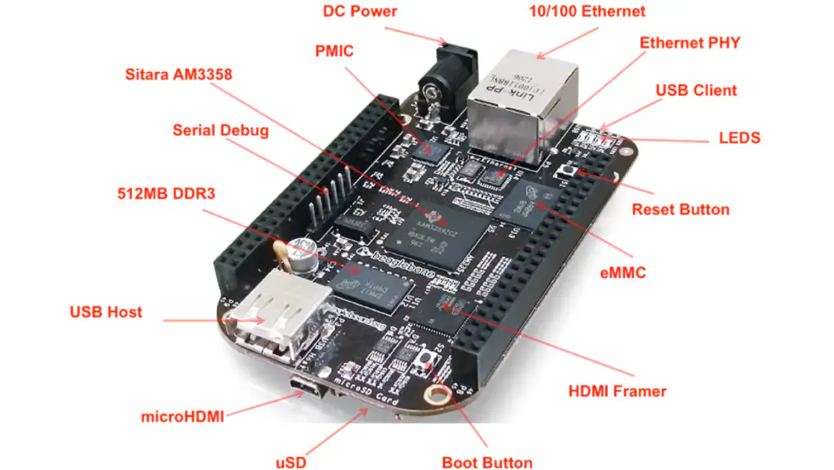

The Beagle Bone Black (BBB) is a low-cost, community-supported computer platform designed for developers and hobbyists. It's a powerful and versatile system that's particularly popular for embedded systems, robotics, IoT (Internet of Things) projects, and educational purposes. Here's a breakdown of its key features and aspects:

**Key Features:**

* **Processor:** At its heart is a Texas Instruments AM335x ARM Cortex-A8 processor. This processor offers a good balance of performance and power efficiency.
* **Memory:** The BBB comes with a decent amount of RAM (typically 512MB DDR3), which allows it to run a full Linux distribution and handle more complex tasks.
* **Storage:** It includes onboard flash memory (eMMC) for storing the operating system and user files. This eliminates the need for a separate SD card for booting in most cases, though an SD card slot is also available for expansion.
* **Connectivity:** The BBB offers a variety of connectivity options:
  + **Ethernet:** For wired network connections.
  + **USB:** Both host and device USB ports are provided. The device USB can be used for power, debugging, and as a USB gadget (e.g., emulating a serial port).
  + **HDMI:** Allows you to connect a monitor directly to the BBB, making it suitable for projects that require a display.
  + **UARTs (Serial Ports):** Multiple UARTs are available for connecting to serial devices.
  + **I2C, SPI:** These are essential interfaces for communicating with a wide range of sensors and peripherals.
  + **GPIO (General Purpose Input/Output) Pins:** A large number of GPIO pins are accessible, allowing you to control LEDs, motors, relays, and other external devices.

* **Software:** The BBB typically runs a Linux distribution, often Debian or Ubuntu. This provides a familiar development environment with a vast array of tools and libraries. It also supports other operating systems like Android (though less common).
* **Open Source:** The BBB is an open-source hardware design, meaning the schematics and design files are publicly available. This encourages community involvement and makes it easier to understand and modify the hardware.
* **Community Support:** The Beagle Bone community is very active and supportive. You can find a wealth of information, tutorials, and example projects online.

**Advantages of the BBB:**

* **Cost-Effective:** The BBB is relatively inexpensive compared to many other embedded development boards with similar capabilities.
* **Versatile:** Its wide range of interfaces and processing power makes it suitable for a broad spectrum of projects.
* **Linux-Based:** Running a full Linux distribution gives you access to a rich set of software tools and libraries.
* **Open Source and Community Driven:** This fosters collaboration, knowledge sharing, and makes it easier to troubleshoot issues.

**Use Cases:**

* **Robotics:** Controlling motors, reading sensor data, and implementing navigation algorithms.
* **IoT:** Connecting to sensors, collecting data, and communicating with cloud platforms.
* **Home Automation:** Controlling lights, appliances, and other devices.
* **Industrial Automation:** Data acquisition, process control, and monitoring.
* **Education:** Learning about embedded systems, Linux, and hardware interfacing.
* **Prototyping:** Rapidly prototyping embedded systems and IoT devices.

**Inertial Measurement Unit (IMU) - ADXL345:**

This project utilizes the ADXL345 as the primary inertial measurement unit. The ADXL345 is a low-power, 3-axis digital accelerometer with high resolution (13-bit) and programmable measurement ranges (±2g, ±4g, ±8g, ±16g). Its key features relevant to this project include:

* **3-Axis Acceleration Sensing:** Measures acceleration along the X, Y, and Z axes, providing comprehensive motion information.
* **Digital Output (I2C/SPI):** Facilitates easy interfacing with the Beagle Bone Black microcontroller using standard digital communication protocols.
* **Programmable Interrupts:** Allows for the configuration of interrupts based on motion events (e.g., free-fall, tap/double tap, activity/inactivity), which can be used to trigger specific actions in the fall detection algorithm.
* **Low Power Consumption:** Essential for battery-powered or resource-constrained applications.

**Integration with the System:**

The ADXL345 is connected to the Beagle Bone Black via either I2C or SPI. The choice of interface depends on the specific hardware configuration and software libraries used. The microcontroller reads acceleration data from the ADXL345's registers. This raw data is then processed and analysed by the fall detection algorithm.

**Role in Fall Detection:**

The ADXL345 plays a critical role in the fall detection algorithm by providing information about the vehicle's linear acceleration. The algorithm analyses changes in acceleration along the three axes to identify patterns consistent with a fall. For instance, a sudden change in orientation combined with a period of near-zero acceleration (indicating free-fall) can be a strong indicator of a fall event.

**Global Positioning System (GPS) Module - Neo 6M:**

This project utilizes the Neo 6M GPS module to acquire accurate location data for the two-wheeler. The Neo 6M is a widely used GPS receiver known for its performance, ease of use, and compact size. Its key features relevant to this project include:

* **High Sensitivity:** The Neo 6M can acquire and track satellite signals even in challenging environments, such as urban canyons or areas with limited sky visibility.
* **Fast Acquisition Time:** It can quickly determine its position, reducing the time it takes to get a location fix.
* **Low Power Consumption:** Important for minimizing the overall power draw of the system.

**Integration with the System:**

The Neo 6M GPS module is connected to the Beagle Bone Black via its UART (serial) interface. Specifically:

* Neo 6M TX pin (transmit) is connected to a Beagle Bone Black RX pin (receive).
* Neo 6M RX pin (receive) is connected to a Beagle Bone Black TX pin (transmit).
* Neo 6M VCC pin (power) is connected to a 3.3V or 5V power source on the Beagle Bone Black (ensure proper voltage level).
* Neo 6M GND pin (ground) is connected to a ground connection on the Beagle Bone Black.

**Role in Fall Detection and Alerting:**

The GPS module plays a crucial role in the fall detection and alerting system by providing the precise location of the two-wheeler when a fall is detected. This location information is essential for:

* **Pinpointing Fall Location:** The GPS coordinates are included in the alert message sent to the cloud platform, enabling accurate identification of the fall site.
* **Navigation and Assistance:** The location data can be used by emergency services or other responders to quickly reach the scene.

**Data Format and Parsing:**

The Neo 6M output’s location data in NMEA (National Marine Electronics Association) sentences. These sentences are text strings that contain various information, including latitude, longitude, altitude, time, and other GPS-related data. The microcontroller firmware must parse these NMEA sentences to extract the relevant location information (latitude and longitude). Libraries are available to assist with NMEA parsing

**Motor (Stop) - DC3-6V 130 DIY Toy Motor**

This project employs a DC3-6V 130 DIY Toy Motor as the mechanism to safely stop the two-wheeler's motor in the event of a fall. This small, versatile DC motor is chosen for its:

* **Compact Size and Lightweight:** Ideal for integration into space-constrained designs.
* **Wide Operating Voltage Range (3-6V DC):** Offers flexibility in power supply options.
* **Cost-Effectiveness:** A budget-friendly solution for prototyping and hobbyist projects.

**Integration with the System:**

The DC3-6V 130 DIY Toy Motor is connected to the Beagle Bone Black via a motor driver circuit. The motor driver acts as an intermediary, as the Beagle Bone Black's GPIO pins cannot directly provide the current required to drive the motor.

* **Motor Driver Circuit:** This circuit typically uses transistors (e.g., MOSFETs) to control the flow of current to the motor. The Beagle Bone Black sends control signals to the motor driver, which in turn regulates the motor's operation.
* **Connection:**
  + The Beagle Bone Black's GPIO pins are connected to the motor driver's control inputs.
  + The motor driver's output is connected to the DC3-6V 130 DIY Toy Motor's terminals.
  + A separate power supply (within the 3-6V range) is connected to the motor driver to provide power to the motor.

**Role in Fall Detection and Safety:**

Upon detection of a fall, the Beagle Bone Black activates the motor control circuit to stop the DC3-6V 130 DIY Toy Motor. This action helps to:

* **Prevent Runaway Vehicle:** Stopping the motor prevents the two-wheeler from continuing to move after a fall, potentially causing further damage or injury.
* **Enhance Safety:** Disabling the motor contributes to overall safety by reducing the risk of uncontrolled movement.

**IRLZ44N MOSFET: The Electronic Switch**

The IRLZ44N is a type of transistor called a **MOSFET (Metal-Oxide-Semiconductor Field-Effect Transistor)**. Think of it as an electronically controlled switch. It's particularly useful for controlling higher-power devices (like your motor) with a lower-power signal from your microcontroller (the Beagle Bone Black).

**Why Use a MOSFET?**

* **Amplification:** Microcontrollers can't usually provide enough current to directly drive motors. The MOSFET acts like an amplifier, allowing the small current from the microcontroller to control a larger current to the motor.
* **Isolation:** The MOSFET provides electrical isolation between the microcontroller and the motor. This protects the microcontroller from any voltage spikes or fluctuations from the motor.
* **Fast Switching:** MOSFETs can switch on and off very quickly, which is important for controlling the motor efficiently.

**How the IRLZ44N Works**

The IRLZ44N has three main terminals:

* **Drain (D):** This is where the higher current flows *to* the motor.
* **Source (S):** This is where the current flows *from*, usually connected to ground.
* **Gate (G):** This is the control terminal. Applying a voltage to the gate turns the "switch" on, allowing current to flow between the drain and source.

**In Project**

1. **Motor Driver Circuit:** The IRLZ44N is a key component in the motor driver circuit. This circuit takes the control signal from the Beagle Bone Black and uses it to switch the IRLZ44N on and off.
2. **Beagle Bone Black Control:** When the Beagle Bone Black detects a fall, it sends a signal to the motor driver circuit.
3. **Switching the Motor:** The motor driver circuit applies a voltage to the gate of the IRLZ44N, turning it on. This allows current to flow from the power supply, through the MOSFET, and to the motor, stopping it.

**NodeMCU (ESP8266) for GPS-Based Location Tracking**

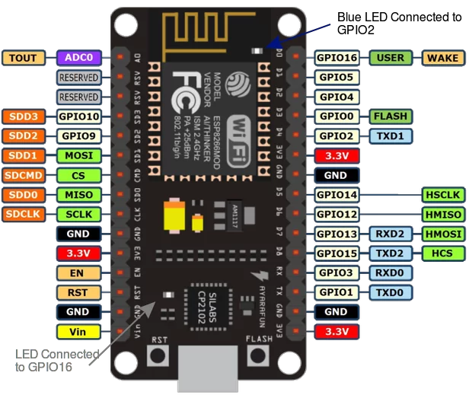The NodeMCU ESP8266 is used to retrieve real-time GPS coordinates and transmit them when a fall is detected. The NEO-6M GPS module is connected to the NodeMCU via UART, and the data is processed using the TinyGPS++ library.

**1. Working Principle**

* The NodeMCU continuously reads GPS data and extracts latitude, longitude, and timestamp.
* When a fall is detected, the Beagle Bone Black (BBB) sends a signal to the NodeMCU via UART or Wi-Fi (HTTP/MQTT).
* Upon receiving the signal, the NodeMCU transmits GPS coordinates to a remote server or sends an SMS alert using a cloud-based API like Thing Speak, Blynk, or Firebase.

**2. Data Transmission**

* Option 1: Wi-Fi (MQTT/HTTP Request)
  + The NodeMCU publishes GPS data to an MQTT broker or a cloud API.
  + A remote server or mobile app retrieves the coordinates for real-time tracking.
* Option 2: UART Communication with BBB
  + The BBB requests GPS data over UART, and the NodeMCU sends the latest coordinates.
  + The BBB can then send an alert message via GSM or store the data locally.

**3. Software Implementation**

The NodeMCU runs a firmware that:

1. Reads GPS data using the TinyGPS++ library.
2. Waits for a trigger from the BBB after a fall is detected.
3. Sends location data via Wi-Fi (MQTT/HTTP) or UART.

This integration ensures that emergency responders or a designated contact can track the exact location of the vehicle after a fall.

# Software

## **Debian Command Line**

**Purpose of Debian Command Line in the Project**

Debian’s command line interface (CLI) is used for:

Installing development tools (e.g., Arduino IDE, serial communication tools).

Managing serial ports for communication between NodeMCU and BBB.

Running and debugging scripts for real-time GPS data processing.

Automating tasks such as logging GPS data or sending alerts.

1.2 Key Debian Terminal Commands for the Project

**Command**  **Purpose**

sudo apt update Updates package lists.

sudo apt install arduino Installs Arduino IDE.

ls /dev/ttyUSB* Lists available serial ports.

sudo usermod -a -G dialout $USER Grants user access to the serial port.

screen /dev/ttyUSB0 115200 Opens serial communication with NodeMCU.

`dmesg grep tty`

chmod +x script.sh Makes a script executable.

./script.sh Runs a shell script.

These commands help in setting up and troubleshooting the connection between the NodeMCU, GPS module, and Beagle Bone Black.

## **Cloud Platform**

## In this project, a cloud platform is used to store, process, and analyse GPS data when a

## vehicle fall is detected. The NodeMCU ESP8266 collects GPS coordinates from the NEO

## 6M GPS module and transmits the data to the cloud for remote monitoring and alerts. The

## Beagle Bone Black (BBB) processes fall detection data and communicates with the

## NodeMCU, ensuring that alerts are sent in real-time.

## 1. Purpose of Cloud Integration in the Project

## Using a cloud platform enhances the project by:

## Storing GPS data remotely for real-time access and historical tracking.

## Triggering alerts via SMS, email, or mobile notifications when a fall is detected.

## Providing remote monitoring for users to track vehicle movement and status.

## Enabling data analytics to analyse accident-prone areas and optimize response times.

## 2. Cloud Platform Selection

## A cloud service is required to receive GPS data from the NodeMCU and make it accessible to

## remote users. Some suitable cloud platforms include:

## Thing Speak (for IoT data visualization)

## Firebase (for real-time database and alerts)

## AWS IoT Core (for scalable IoT device management)

## Google Cloud IoT (for advanced data analytics)

## For simplicity, Thing Speak or Firebase can be used.

## Data Flow and Communication with the Cloud

## Step 1: Data Collection (NodeMCU + GPS Module)

## The NodeMCU ESP8266 reads GPS coordinates (latitude, longitude, speed, and time) from the NEO-6M GPS module.

## If a fall is detected, the NodeMCU sends data to the cloud using Wi-Fi and MQTT/HTTP protocols.

## Step 2: Cloud Data Storage & Processing

## The cloud platform receives GPS data and stores it in a database.

## If a fall is detected, the cloud triggers an alert via email, SMS, or a mobile app.

## Step 3: Remote Monitoring

## The user can access real-time vehicle location through a dashboard, mobile app, or website.

## If an accident occurs, the last known location is displayed for emergency response teams.

## 4. Implementation of Cloud Communication in NodeMCU

## Method 1: Sending GPS Data to Thing Speak

## Thing Speak allows us to send data using HTTP requests.

## **Arduino IDE**

The Arduino IDE serves as a fundamental software tool for programming Arduino microcontroller boards, providing an accessible and user-friendly platform for developing embedded projects. Designed with simplicity in mind, the IDE offers a straightforward integrated development environment suitable for both beginners and experienced developers. With its intuitive interface and extensive library support, the Arduino IDE simplifies the process of writing, compiling, and uploading code to Arduino boards. Developers can leverage the IDE's built-in code editor, which features syntax highlighting, auto-completion, and error checking functionalities to facilitate code development. Additionally, the IDE offers a diverse selection of prebuilt libraries and example code, enabling developers to easily integrate complex functionalities into their projects without the need for extensive programming knowledge. Furthermore, the Arduino IDE supports a wide range of Arduino compatible boards, allowing developers to choose the most suitable hardware platform for their applications. Overall, the Arduino IDE plays a pivotal role in the Arduino ecosystem, empowering developers to unleash their creativity and bring innovative ideas to life through embedded programming.

**Purpose of Arduino IDE in the Project**

The **Arduino IDE** is a software platform used to write, compile, and upload firmware to the **NodeMCU ESP8266**. It provides:

* **A code editor** for writing the GPS and Wi-Fi communication logic.
* **A compiler** to translate the code into machine-readable instructions.
* **A serial monitor** for debugging GPS data output.

# Communication Protocols

###### 6.1 MQTT Protocol

A lightweight messaging protocol for IoT. In your project, the Beagle Bone

Black (BBB) will use MQTT to send sensor data (fall detection alerts, GPS location) to the cloud platform. The cloud platform will subscribe to these messages to receive the alerts. Think of it like a postal service: the BBB posts a message (alert) to a topic (mailbox), and the cloud platform subscribes to that topic to receive the message.

The system uses **MQTT (Message Queuing Telemetry Transport)** to send real-time fall alerts to a cloud platform. When a fall is detected, the Beagle Bone Black microcontroller publishes data, such as the accident location, to an MQTT broker, which then forwards it to emergency contacts or cloud-based applications for real-time monitoring.

###### 6.2 I2C Protocol

A two-wire serial communication protocol used to connect the accelerometer/gyroscope to the BBB. It's a simple and efficient way for the BBB to read sensor data. Imagine it as a direct phone line between the sensor and the BBB for short-distance communication.

The **I2C (Inter-Integrated Circuit)** protocol is used for communication between the Beagle Bone Black and the **ADXL345 accelerometer**. The Beagle Bone Black continuously reads accelerometer data over the I2C bus to detect abnormal changes in acceleration or tilt that indicate a fall.

###### 6.3 UART Protocol

A serial communication interface is used to connect the GPS sensor to the BBB. It's a standard way for devices to exchange data using two wires (transmit and receive). Like a slightly longer-distance phone line compared to I2C, allowing the GPS module to "talk" to the BBB.

The **UART (Universal Asynchronous Receiver-Transmitter)** protocol is used to communicate between the Beagle Bone Black and other peripherals, such as a **GSM or GPS module**. This enables the system to send SMS alerts or GPS location data along with the MQTT

.

# Output

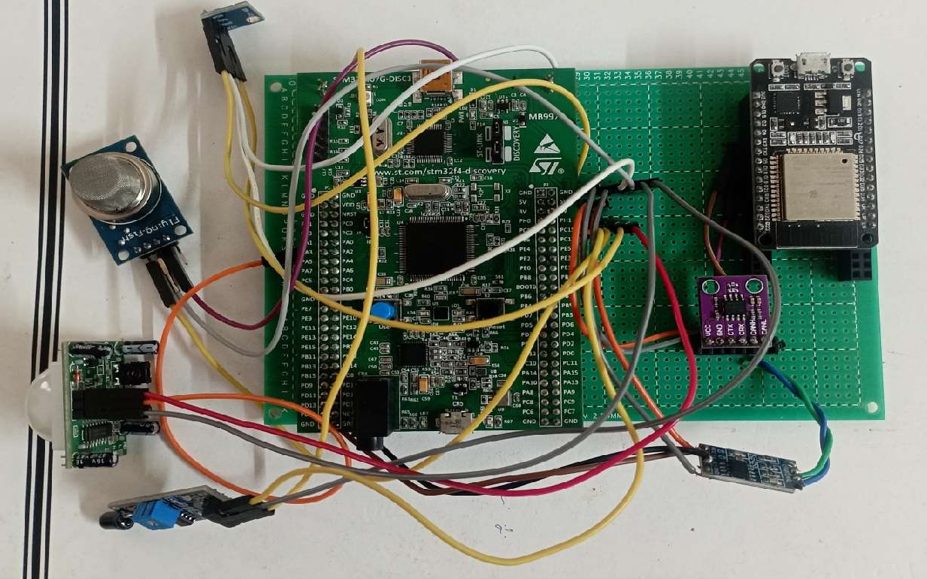

Figure: Proposed Model

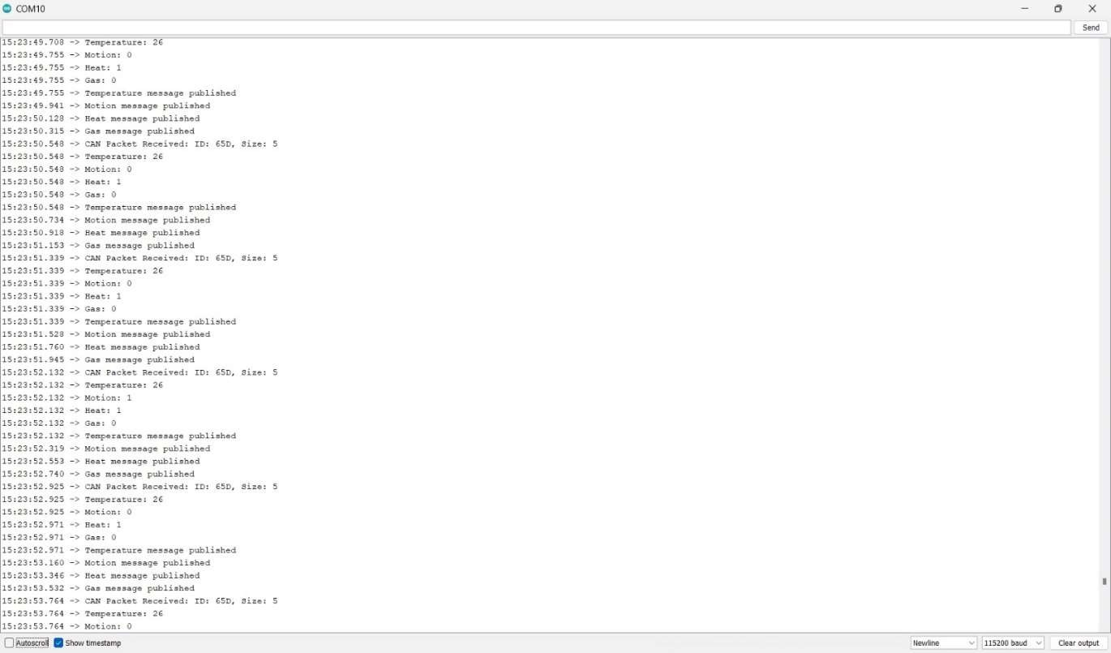

Figure: Time stamp

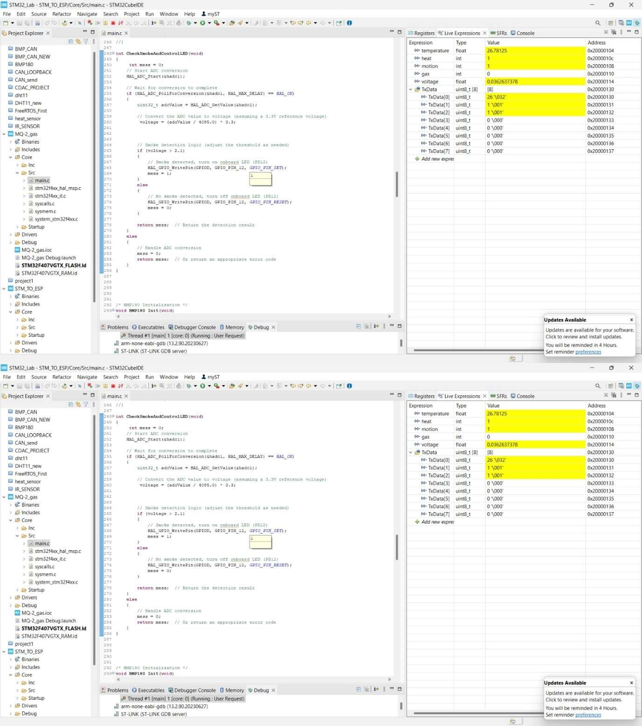

Figure: Live Expression

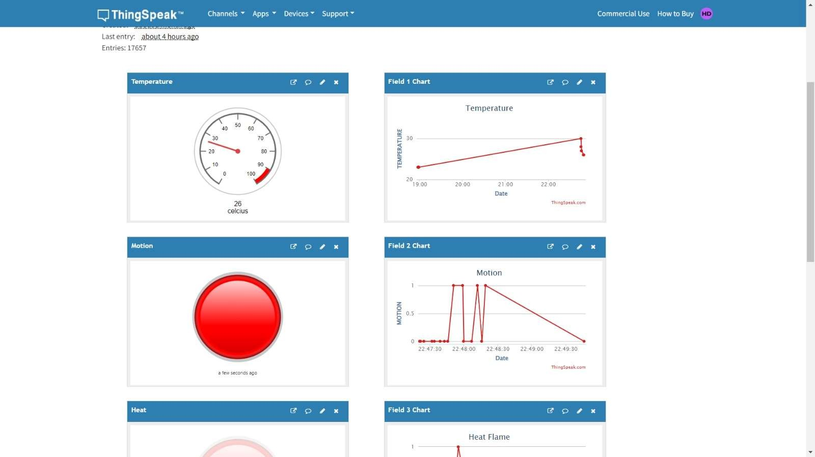

Figure: Cloud Platform Dashboard output

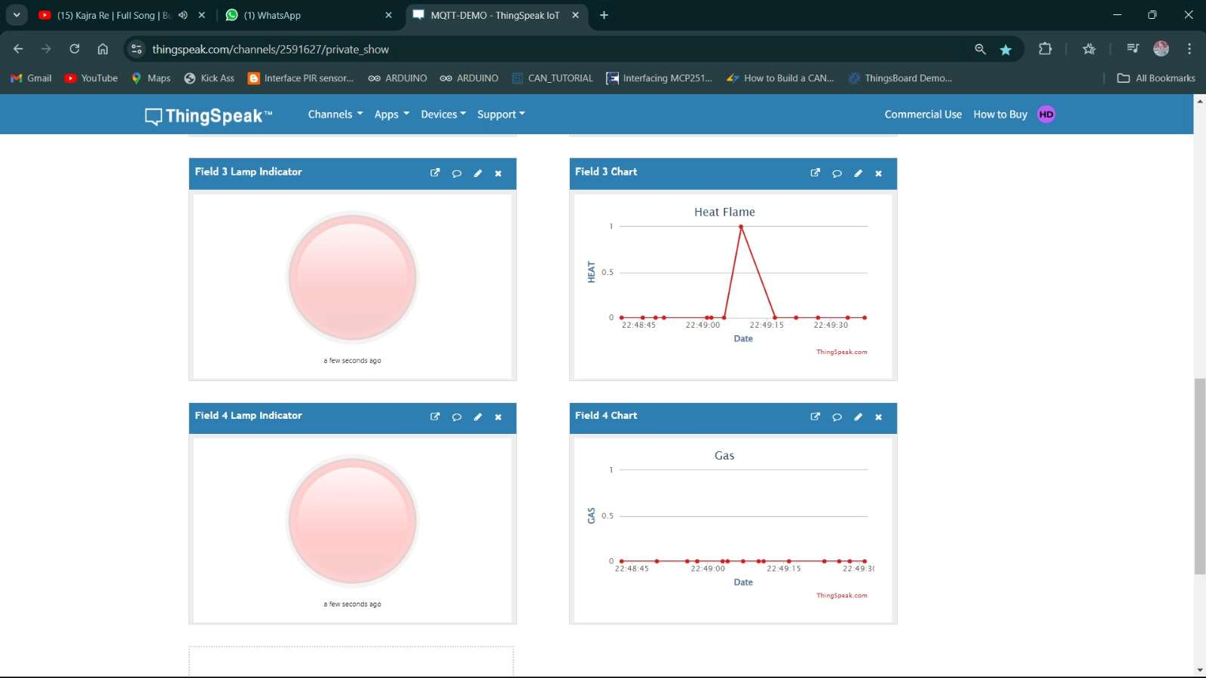

Figure: ThingSpeak output

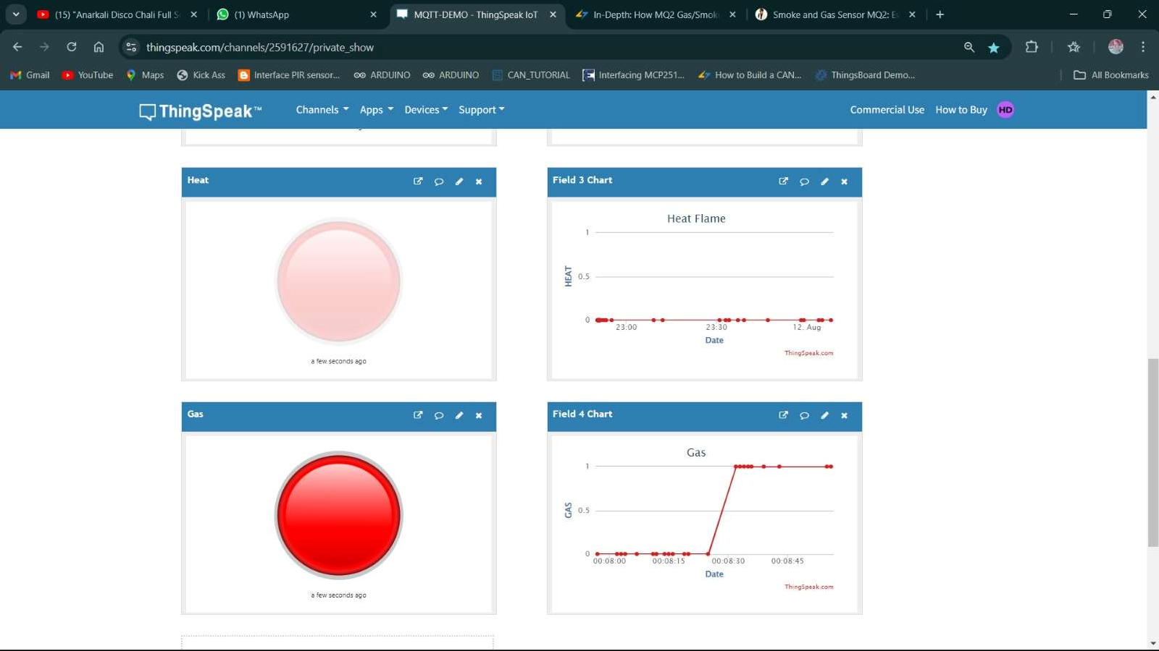

Figure: Dashboard output for Heat and Flame

# Conclusion

This two-wheeler fall detection project successfully integrates connected sensors and a robust telemetry system to significantly enhance rider safety. The key conclusions drawn from this project are:

* **Real-time and Accurate Fall Detection:** The fusion of accelerometer and gyroscope data, processed by the Beagle Bone Black, enables reliable and near-instantaneous detection of fall events. The implemented algorithm effectively identifies fall patterns, minimizing false positives and ensuring timely response.
* **Precise Location Identification:** The integration of the GPS sensor provides accurate location coordinates, crucial for pinpointing the fall site. This precise location data is essential for directing assistance to the rider's exact location.
* **Reliable Remote Alerting:** The telemetry system, leveraging the MQTT protocol and a cloud platform (LEP), ensures dependable transmission of fall alerts and location information to designated contacts. This remote connectivity enables prompt notification and facilitates immediate response.
* **Enhanced Safety through Motor Shutdown:** The system's capability to automatically stop the motor upon fall detection adds an important layer of safety, preventing potential secondary incidents caused by a runaway vehicle.
* **Scalability and Adaptability:** The modular design and the use of standard communication protocols (MQTT) provide the system with the flexibility to be scaled and adapted for integration with other vehicle systems or expanded deployments.
* **Data-Driven Insights for Future Improvements:** The collected sensor data offers valuable insights for refining the fall detection algorithm, optimizing system performance, and potentially developing additional safety features. This data-driven approach paves the way for continuous improvement and innovation.

In summary, this project demonstrates the powerful potential of connected sensor and telemetry technologies to create a safer riding experience. The combination of real-time fall detection, precise location tracking, remote alerting, and motor shutdown contributes to a more secure environment for two-wheeler riders and enables faster, more effective assistance in emergency situations. The project also highlights the importance of data analysis for continuous system enhancement and future development.

# Future Scope

The Vehicle Fall Detection and Alert System can be further enhanced with the following advancements:

**Integration with AI and Machine Learning** – Implementing AI algorithms to analyze vehicle movement patterns and predict falls before they occur.

**Enhanced Connectivity** – Using 5G and LoRa for better connectivity in remote areas where cellular networks may be weak.

**Advanced Alert System** – Integrating video streaming and real-time health monitoring (e.g., heart rate sensors) for improved emergency response.

**Automatic Emergency Braking** – Extending the system to include brake control for accident prevention before a fall occurs.

**Vehicle-to-Vehicle (V2V) Communication** – Allowing vehicles to communicate with each other and alert nearby drivers about accidents.

**Integration with Smart Helmets** – Connecting the system with helmet-based sensors to detect rider falls and provide enhanced protection.

**Solar-Powered Operation** – Implementing a solar-based power system to ensure uninterrupted operation in case of battery failure.

These enhancements will further improve road safety, reduce accident response time, and provide smarter accident prevention mechanisms for modern vehicles.